Standard Life Requests

Purpose

To determine if an advisor is eligible for a Standard Life Code set-up and to provide the information to Standard Life in order to do the code set-up.

Background
Due to Manulife’s acquisition of Standard Life Canada, Manulife advisors may wish to sell Standard Life seg products. If a Standard Life advisor wishes to sell MLI products, the normal contracting process will need to be completed. Advisors with only London Life, FundSERV, Manulife Bank, or Group codes do not qualify for this agreement.
Once research is completed and it is determined the advisor qualifies for a Standard Life code, templates are completed and sent to Standard Life. Standard Life will set up a code and will send a Welcome Letter to the advisor and cc Support Services advising the code and branch details. The new SL code then needs to be added to DSS.
SLA: To be reviewed and processed same day when received before 4pm EST.

Code Movement - how to move a Standard Life code from one MLI code to another in DSS

Distribution Channels Database - how to locate the Contracting contact at an MGA using the DCD

Step | Action
1 | Open new e-mail in DS New Contract Administration folder:  Is this a new SL Code Setup Request? Actions:  Yes Create CSD in AWD: Business Area - DISTSERV Work Type – ADVSRSETUP Status - READY The CSD should contain an e-mail or note of setup, First Name & Last Name of advisor. *NOTE: If the new SL code is required for the Corporation, Create a CSD in AWD as well.  Yes, for an Incorporation Setup. You will receive an internal e-mail indicating a SL code is needed because of an Incorporation Setup. *NOTE: Under an Incorporation, - MLI – A GAB becomes a GABR under a new corp. The GAB code is reused and transformed into a GABR code. - SL – A vested advisor becomes an NVEST of a BVEST. The vested code is reused and transformed into an NVEST code. - Create a CSD in AWD for the advisor & Corporation. - Search advisor’s MLI code in DSS, determine which SL code attached to the MLI code to re-use. **If no SL code is attached to MLI code, proceed to the next step of normal process to set up a new code. - Use the corporation’s MLI code to set up the corporation on CAPSIL. - Update Mail NAAD on the advisor’s SL code to the Mail NAAD of the corporation. - Ensure the information on Capsil matches DSS. (e.g., License, address, phone #). - Reply to original e-mail, indicating which SL Code to use. See Appendix B for template. - Update Tax Spreadsheet with details from request. - Go to the current year & open the spreadsheet for Mail NAAD changes. - Fill the columns under the “FOR LOGGING MAIL NAAD CHANGES” section. - Save the spreadsheet. - Go to step 21 to add new Corporate SL Code to DSS. PEND1 the CSD for CAMS setup.  No, but it is for a Pended SL Code Setup Request (i.e.. the e-mail contains additional SL information you have requested) Search for CSD in AWD Business Area – DISTSERV Work Type – ADVSRSETUP First Name – First Name of the Advisor Last Name – Last Name of the Advisor Locate the appropriate CSD and attach the e-mail containing additional info to the CSD. Continue with your setup from where you left off.  No, but it is Contracting related Move e-mail to DS New Contract Administration Inbox.  No, and NOT related to SL Code Setup Request E-mail was from… Steps Comp MFC (The DCC) Advise that this is not a Standard Life Code Setup Request. Unfortunately, our team only handles new SL Code Setup Requests, we are not the ones that process transfers, commissions, etc. Any other sender Forward the e-mail to COMP MFC (the DCC). Advise that this is not a Standard Life Code Setup Request, please forward to the correct team to handle accordingly.
2 | Does the request contain sufficient information to proceed? (ie. name, MLI code)  If Then  Yes Continue to the next step below.  No Reach out to requester for more information – See Appendix E for template. - Pend the CSD. - Add a note that you’ve reached out for additional information.  **Note: Corp codes can be set up, but first we need to know which advisors under the corp require SL codes (including Group).
3 | Access DSS. Using Global Search and the Operator LIKE, enter the First Name and Last Name of the advisor, or Search by MLI Selling Code if provided.
4 | Is the advisor active with Manulife?  If Then  Yes Continue to the next step below.  No Send rejection e-mail (Appendix F). - NPW the CSD. - Attach rejection e-mail to CSD.  **Note: SL codes may be requested and added to pended MLI codes.
5 | Is the advisor under IAC, NAC or CAC?  If Then  Yes (Advisor is active with IAC, CAC and/or NAC, excluding London Life, Group Only) Proceed to the next step. **Note: - Investors Group (IG) advisors are allowed to service SL policies. - Life Specialists qualify for a SL code. Check if an active INDR code exists under the same Party ID. - If yes, proceed with the request using the INDR code details and link accordingly to the INDR code on DSS when the SL code is returned. - If no, (no active INDR code exists, only LS), proceed using the LS code details and link according to the LS code on DSS when the SL code is returned.  No (Advisor only has London Life, FundSERV Only, Bank) Send rejection e-mail (Appendix D - Declined as suitable Manulife contract is required). - NPW the CSD - Attach Rejection e-mail to CSD.  **Note:  - PlanRight codes do qualify for the issue of SL codes as there are not any exclusions of product shelf (assuming it’s the Friends and Family code that they actually get paid on). PlanRight is a Manulife program, not an entity, and therefore has neither a licence nor E&O. The advisors are Manulife employees who are individually licensed, not corporately licensed. Anyone under a PlanRight code gets paid a salary. We don’t pay the advisors the commissions so not EFT information exists in FASAT.  - Dealer Channel Manulife Securities codes do not qualify. However, an active CAC - Manulife Securities Insurance Inc code with a FundSERV Rep code attached does qualify. (Manulife Securities Insurance Inc (MSII) is the Securities advisor's relationship to sell Insurance products from Manulife and other Carriers. Any business sold under this relationship is paid to MSII. Codes appear as GAB in DSS and FASAT but PXR to the MSII branch.)  - SL codes cannot be linked to HO codes. Contract Types Quick RePRference Guide
6 | Is the e-mail requesting a Group code?  If Then  Yes Is the active MLI code… Steps A Group Only code 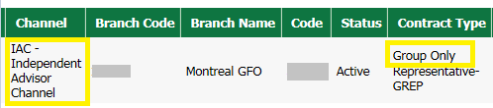 1.Check the DSS to determine: - If the Group Only MLI code already has an existing SL Code attached, reply with the existing SL Code. - If the Group Only MLI code does not have an existing SL Code attached, proceed to step 10 to have one created. 2.Look for the region on the Branch name in DSS and refer on the list below for the branch code. A CAC or NAC code 1.Search the Distribution Channels Database (Stoplights) by branch number. 2. Determine if the code/branch is eligible to sell Group business: - If yes, and advisor already has an SL Code, reply with the existing SL Code. - If yes, but advisor does not have an SL Code, proceed to next step. - If no, respond to the requester advising we are unable to proceed. See Appendix G for template. 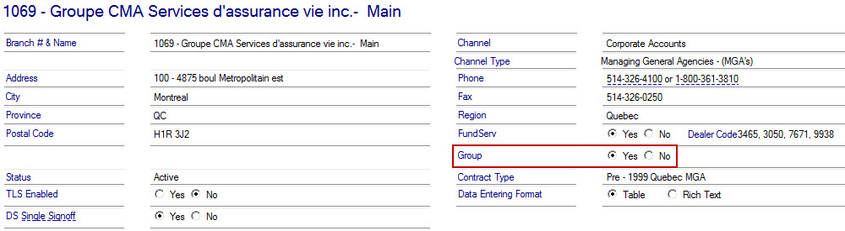 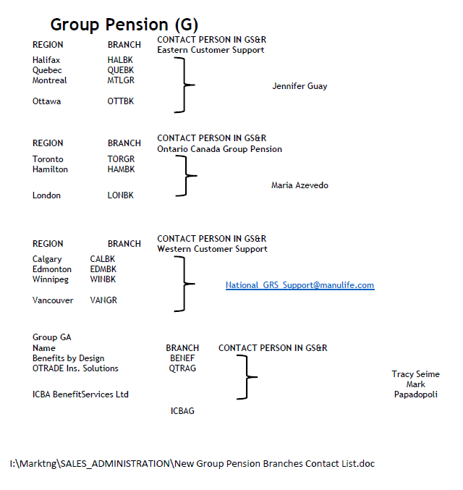  No Proceed to the next step.
7 | Verify the Standard Life branch code under which to set up the new SL code  Before setting up a new SL code, you must determine under which branch code it should be set up. Refer to the Hierarchy in DSS to figure out AGA/MGA/etc.  NOTE: For advisors under the Independent Advisor Channel (IAC), the SL branch is always MANLF.  - Look up the GA (or AGA, if applicable, or NA) in SAS. Try to enter as much of the name provided as possible to obtain the lowest number of results.  ALTERNATIVE: Do lookup in Copy of SAS branches Excel spreadsheet and/or use Branch Cheat sheet Excel spreadsheet I:\Commissions\Standard life code SET-UP  - If there is an AGA listed on DSS, look the name up on SAS. You will set up the new code under this AGA branch code.  - If more than one result looks like it could be the GA or AGA from DSS, you need to:  - Verify the address  - Compare the regions of the branch in SAS  - If you are uncertain about the branch verification, check with a contracting analyst.  Tip: Leave SAS open displaying the branch information you looked up. It will be useful during code setup.  - Note that you will find any pertinent information to your code setup in SAS notes.  - If still unsure, look up MLI branch code in DSS and look for equivalent SL branch  - Using MLI branch code, do lookup in “Code” field:  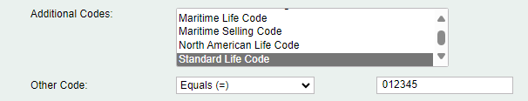  - Look in “Additional Code and Additional Code Type” column for Standard Life code and corresponding branch:  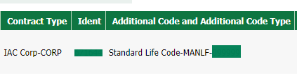  - If there is more than one SL code associated with the MLI branch, look at the hierarchy of the branch to find a specific advisor who has an SL code. Click on the names of the advisors in the branch hierarchy to find their codes. A new window for “Party Summary” will open; look in top right corner:  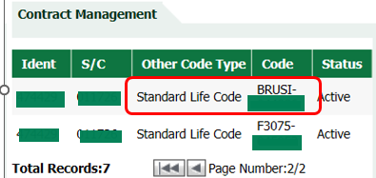
8 | Verify if the advisor has existing Standard Life codes  1. Check the Additional Code field in DSS for an existing Standard Life code.  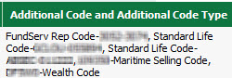  - Use CAMS to check if the advisor has an existing SL code that mirrors the Manulife selling code  - Open CAMS and login using mainframe ID and password. Once the below window opens, click on “Broker Admin”  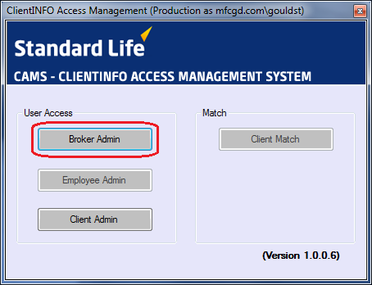  - A new window will open. In the bottom left hand corner, click on Advanced Search to lookup either an individual name or corporate name.  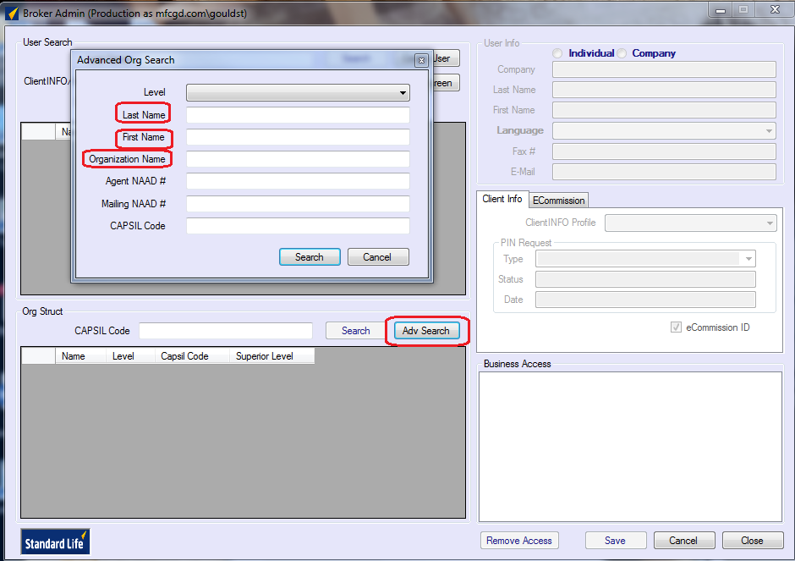  - Tip1: for the First Name field, use only the first 2 or 3 letters of the advisor’s first name to ensure you find possible nicknames; ex: search for Jen instead of Jennifer.  Search:  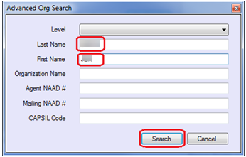  Results:  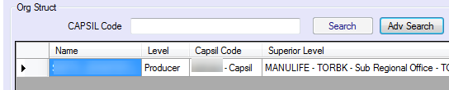  - Tip2: for the Organization Name field, if the corporation name includes “Financial Services”, omit this from your first search and then if necessary, narrow your search by adding “Fin”. Many corp names are abbreviated in Capsil as variations of Fin. Servs. and can be hard to find. Ex: search for “Grant Sheridan” instead of “Grant Sheridan Financial Services Inc.”  Search:  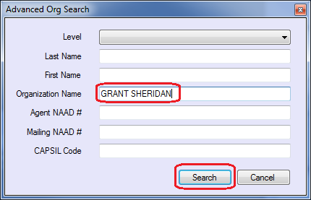  Results:  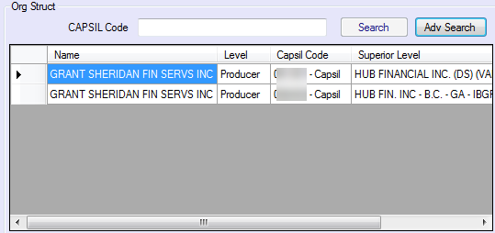  - If there is one or more result that could match the advisor in question, look up the code in Capsil to determine whether it can be used or not.  - Take the following action depending on your search results:  Search Results Action  No code / Code is terminated in CAPSIL Create a new code under branch that is on DSS  Advisor has codes under another branch Create a new code under branch provided on DSS  Advisor has a code under the branch requested BUT the relationship is different than the active relationship on DSS No need to continue with advisor code setup. Check the existing active code if it has a business & payable balance: - YES – Email the transfer to request to lower the minimum and wait for the ADS to be provided. Once done, proceed to update the code on CAPSIL and DSS. (If there is a NAAD Changes – Please log it on our Tax list of Mail NAAD Changes spreadsheet: I:\Commissions\Tax) - NO – Email the transfer and just wait for the ADS, once provided then proceed to update the code on CAPSIL and DSS.  Advisor has a code under the branch requested AND the relationship matches DSS No need to continue with advisor code setup. Email the transfer and just wait for the ADS, once provided then proceed to update the code on CAPSIL and DSS. - Verify that the information from Capsil matches DSS and FASAT. Apply any necessary updates (e.g., License, banking, address, phone #). (If there is a NAAD Changes – Please log it on our Tax list of Mail NAAD Changes spreadsheet: I:\Commissions\Tax) - Do a code movement on DSS (If needed) 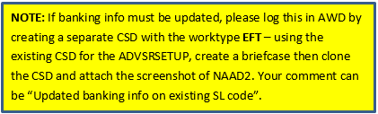  Does the advisor already have an SL code that can be used?  If Then  Yes Respond to the requestor advising code.  No Proceed to the next step.
9 | Use this chart to determine information regarding your setup:  What is the advisor’s Contract Type in DSS? Broker’s Corporation Name Broker Vested or Non-vested? If Vested, is the Broker under a Rep-Entitled Corp? If non-vested, who is the BVEST? 3 Tier? Use EFT info in FASAT for:  GAB/SGAB, GIND N/A Vested Leave blank Leave blank No Advisor  GAB (MS branch) Manulife Securities Non-vested Leave blank Manulife Securities No CAC (payee code)  GABR/SGABR/ GABCB/SGACB, GREP, GCRPB GABC, GABCE, GCRP Non-vested Leave blank BVEST = Corporation No Corporation  GABR (reporting controller = MGA Assante) Reports directly to GA Assante Non-vested Leave blank Assante Estate and Ins Servs Incc No Assante’s banking  GABR/SGABR of a Sched. B Corp-Entitled Corp (under GABCB) GABCB/SGACB Non-Vested Leave blank BVEST = Corporation (main corp) Yes GABC (main corp) To find the main corp code, search the GABCB Code in DSS Global Search and use the reporting controller code  GABR/SGABR of a Sched. B Rep-Entitled Corp (under GABCE) GABCE/SGACE Non-Vested Leave blank Sched. B Corporation Yes GABCE (Sched B Corp)  GABRE/SGABRE GACRE Vested Corporation Leave blank No Advisor (**Check DSS if advisor is an owner. If yes, check FASAT to see if payment is directed to GACRE)  INDIV/SIND N/A Vested Leave blank Leave blank No Advisor  REP/SREP, CORPB/SCRPB CORP Non-vested Leave blank BVEST = Corporation No Corporation  REPE, CORPE CRPRE Vested Corporation Leave blank No Advisor (**Check DSS if advisor is an owner. If yes, check FASAT to see if payment is directed to CRPRE)  REP/SREP of a Sched. B Corp-Entitled Corp (under CORPB) CORPB/SCRPB Non-Vested Leave blank BVEST = Corporation (main corp) Yes CORP/SCORP (main corp) To find the main corp code, search the CORPB Code in DSS Global Search and use the reporting controller code  REP/SREP of a Sched. B Rep-Entitled Corp (under CORPE) CORPE Non-Vested Sched. B Corporation Leave Blank Yes CORPE (Sched B Corp)  ICIND n/a Non-vested Leave blank NA Firm Name (branch name) No NAC (payee code)  ICREP ICCRP Non-vested Leave blank NA Firm Name (branch name) No NAC (payee code)  INDR INDC Non-vested Leave blank NA Firm Name (branch name) No NAC (payee code)  Life Specialist Corp Name Non-vested Leave blank NA Firm Name (branch name) No NAC (payee code)  **Note:  - Standard Life codes can be linked to a Servicing Only code.  - **To determine if advisor is Schedule A (owner of corp), check Notes in both DSS and FASAT. If advisor is listed, EFT provided should be that of the advisor. If not, provide EFT of the corporation. If Schedule A notes do not exist:  - Search the corporation in DSS and select the Relationship tab.  - Review the Party Name and Party Role.  - If there is an advisor's name with the role of “Owner”, the advisor is a Schedule A.  - If there is no name or different name shown, the advisor is not a Schedule A.  - Advisor pays to itself.  - To determine Corporation and NAC payee, obtain corp selling code (by searching Field Force of the advisor code to obtain Payee) > locate corp Ident > search the corp Ident in FASAT.  - For GAB (MS branch), GABR (reporting controller = MGA Assante), Life Specialist, ICIND, ICREP and INDR use the Advisor code for rates.
10 | Create the advisor code in CAPSIL, assign a client number (aka NAAD) as follows:  - Go to NAAD screen in Capsil: use the End key on your keyboard to clear the CLIENT NUMBER field, tab to the ENTER field and change the I to A (for Assign) and hit the enter key.  - Enter the advisor’s information from DSS into the appropriate fields  **Note: For French names (either indiv or corp), never use accents in Capsil.  Pay attention to this when copying/pasting names. Accents cause formatting errors.    Example of corporate advisor:  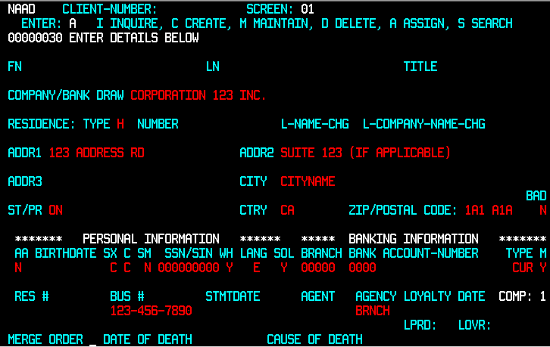  Example of individual advisor:  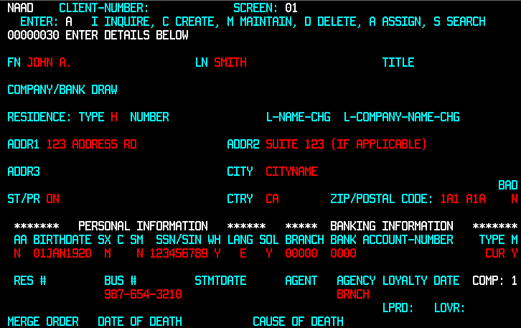  Blank NAAD 01:  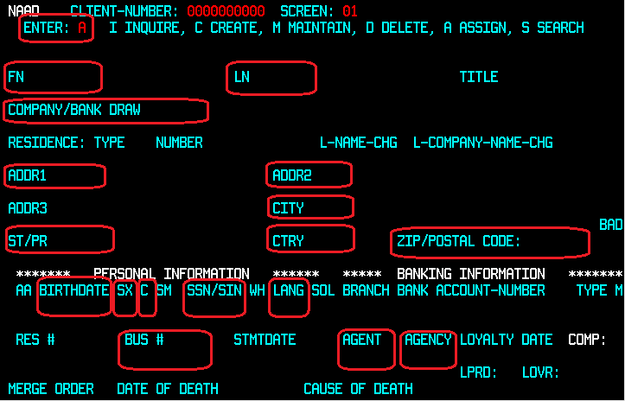  A. Enter: Type ‘A’ in this field and press Enter.  B. FN: Enter the advisor’s first name as shown in DSS. Leave blank if a corporation.  C. LN: Enter the advisor’s last name as shown in DSS. Leave blank if a corporation.  D. COMPANY/BANK DRAW: If a corporation, enter the name.  E. ADDR1, 2, 3 and CITY: Refer to DSS (Contact Tab) for the advisor’s full business address.  F. ST/PR: Enter the code corresponding to the advisor’s province from the list below:  Alberta=AL Nova Scotia=NS  British Columbia=BC Ontario=ON  Manitoba=MA PEI=PI  New Brunswick=NB Quebec=QU  Newfoundland=NF Saskatchewan=SA  Northwest Terr/Nunavut=NT Yukon=YU  G. CTRY: Leave the default code (CA for Canada).  H. ZIP/POSTAL CODE: Enter the advisor’s postal code using format XXX XXX. Ex: A1A 1A1  I. BIRTHDATE: If an individual, enter advisor’s birthdate found in DSS under General Tab (General Info) Format is DDMMMYYYY. Ex: 25DEC1950  J. SX: Enter ‘M’ or ‘F’ for the advisor’s gender found in DSS under General Tab (General Info). If the advisor is a corporation, enter ‘C’.  K. C. This is the Company code. If the advisor is an individual, leave blank. If the advisor is a corporation, enter ‘C’.  L. SSN/SIN: Enter the advisor’s Social Insurance Number from DSS (Banking Tab). Leave blank if a corporation.  M. LANG: E is the default. Refer to the preferred language indicated on DSS in the Communication Preferences.(F for French)  N. BUS #: This is the business phone number of the advisor. Found in DSS under Contact Tab)  Format: 000-000-0000. If no number is indicated, use the GA number found in SAS. Note that extension numbers cannot be included.  O. AGENT: Leave the agent code blank for now. Once you create the advisor code on the AGNT 1 screen, you will input it in this field.  P. AGENCY: Enter the SL branch code (5-letter code found in SAS)  - Press Enter twice.  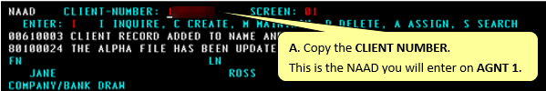
11 | Enter banking details from FASAT on NAAD 02.  **Note: Skip this step for INVEST codes.  When the advisor is non-vested (meaning commission are directed to a corporation), check the hierarchy in DSS to see who is the BVES (the corp) because the banking information on NAAD02 for the BVEST code will need to be set up. If the corporation has an existing SL code, check to see the banking is up to date.  1. FASAT Lookup  - In DSS, lookup the MLI selling code  - Copy the IDENT code:  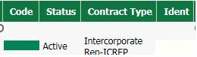  - Access FASAT: Fasat - Welcome to Fasat, and Go to CLIENT  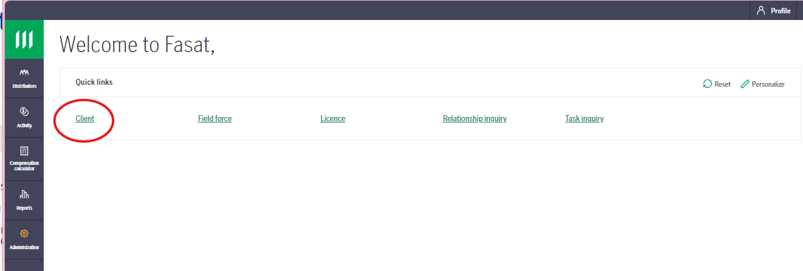  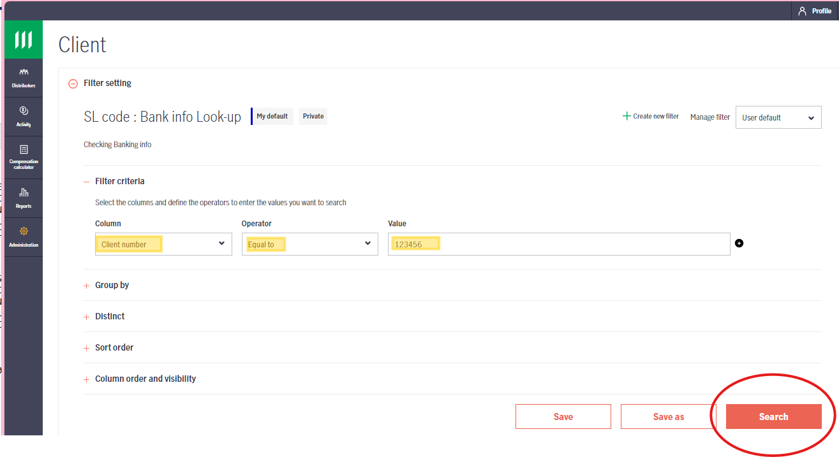  - Pull up client information and go to banking tab.  If there is more than one line of banking information, select the line with the most recent effective date.  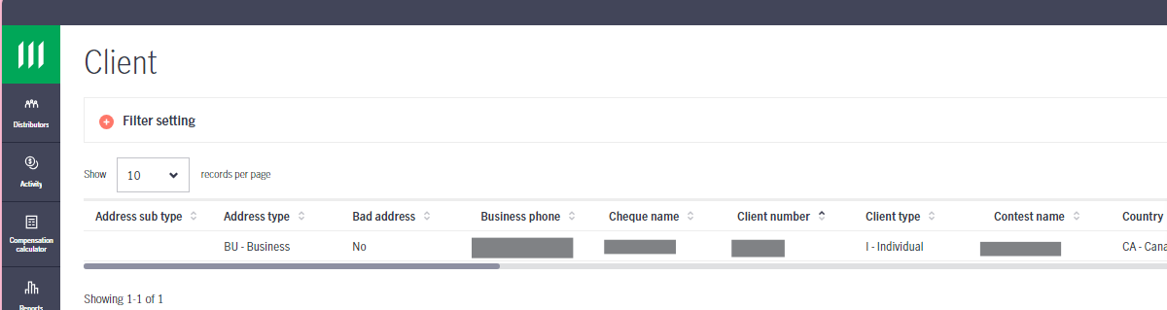  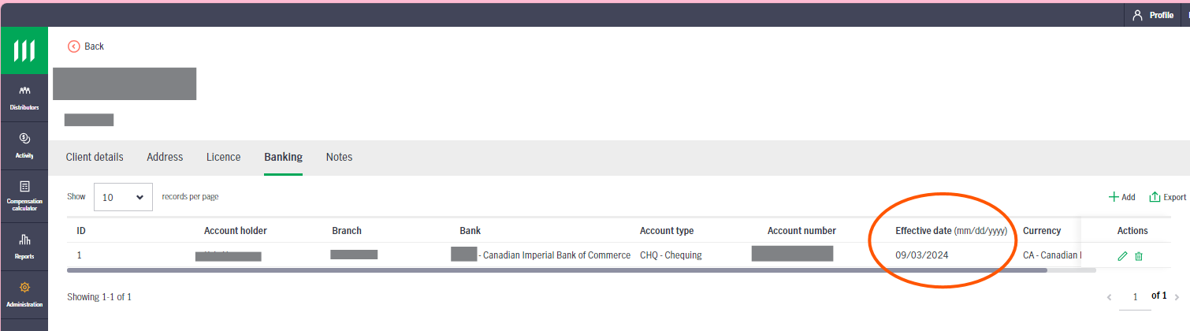  - Copy banking info onto Capsil NAAD 02  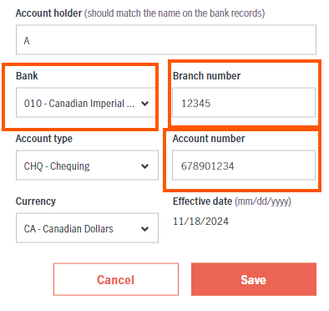  - Bank # (always 3 digits)  - Transit # (aka Branch Number - always 5 digits Branch number)  - Account #  **Note: When CAC - Manulife Securities Insurance Inc code, ensure the account holder and banking is MSII.  2.Check if commissions are paid up to the branch:  - Access FASAT and go to “Field Force”  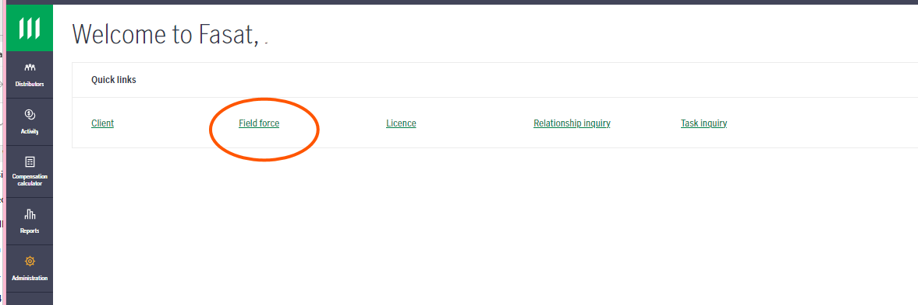  - Search by using the MLI Selling Code in the VALUE field.  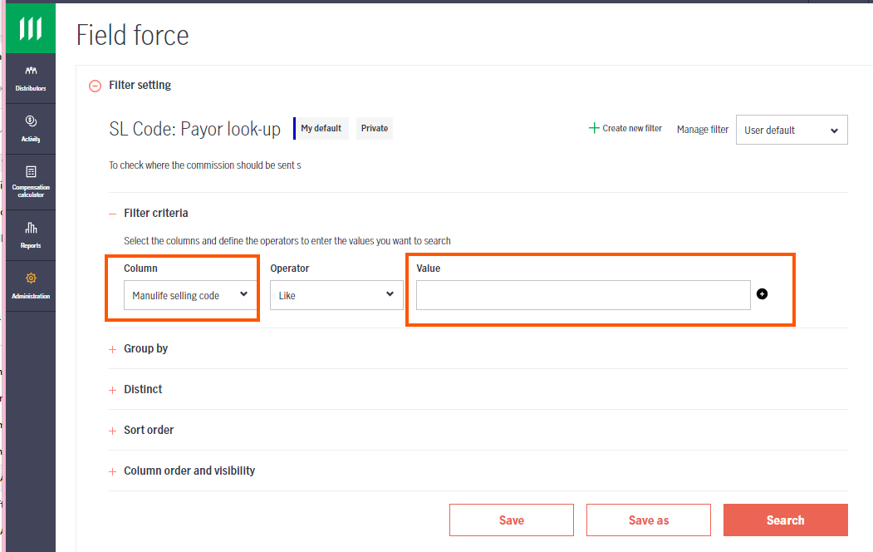  - Click the MANULIFE SELLING CODE  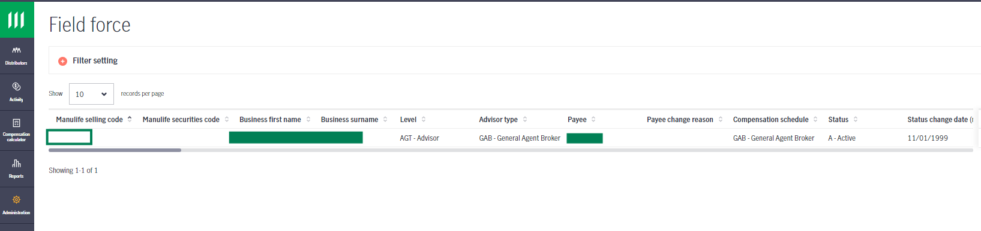  - Go to Banking tab and Check Payment Method:  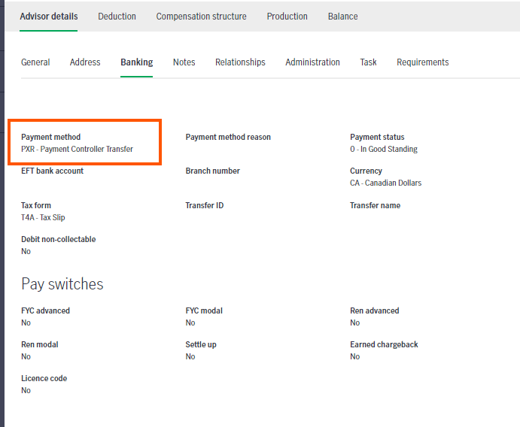  Payment Method is… Actions  XFR Check Transfer ID for MLI code. This is where commissions are going. If needed, look up code in FASAT Client Side for banking details.  PXR Payment is being forwarded to the Payment Controller listed under the “General” tab. Check the Payee in FASAT.  Anything else (CHQ and EFT) Proceed with next steps.  3.Entering information onto NAAD 02  - Is the Advisor Vested or Non-Vested? (Check Step 12 for additional information)  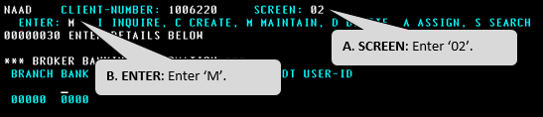  Complete this step if the advisor is vested or a corporation (BVEST).  - Enter M for maintain and enter the banking details  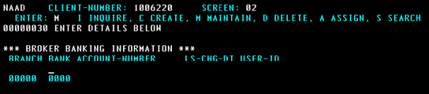  - BRANCH: Enter the 5-digit branch transit code.  - BANK: Enter the 3-digit bank code and press TAB.  - ACCOUNT NUMBER: Enter the bank account number.  - Press Enter.  The two protected fields: LS-CHG-DT and USER-ID now display today’s date and the Capsil user identification code. This data is used to track changes to the advisor’s banking details.  - Press Esc key to clear your screen.  Banking details recap  Setup Type Action  Individual Advisor – vested Enter banking details on NAAD 2  Individual Advisor – non-vested (NVEST) Do NOT enter banking details on NAAD 2  Corporate (BVEST) Enter banking details NAAD 2 (if code exists double check to ensure info up to date)  **Note: If you require to delete Banking info on NAAD, please refer to Appendix C.
12 | Check if there is a garnishment/garnishee attached to the MLI code  Standard Life Garnishee Check:  Check AGNT 01 of each code and verify if the GARNISHEE field is Y or N. If Y, new SL code will need to be set to Y – refer to Garnishee procedure.  Manulife Garnishment Check:  - Check the Advisor’s Financial History Tab on DSS  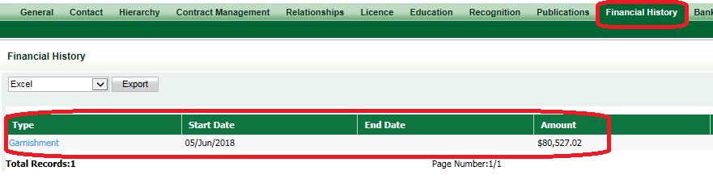  *Note: If you require additional assistance regarding Garnishment, please reach out to a Specialist at DS_Contracting@Manulife.com.  - Does the advisor have an active garnishment (end date is blank) on DSS?  If Then  Yes - Look up the advisor’s garnishment on AWD: - Business Area = DISTRIBUTN - Work Type = LEGALREQST - Advisor Last Name/First Name - Note: Backdate the Date Range if needed 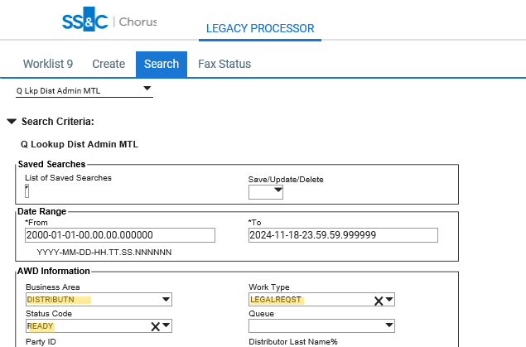 - Find the applicable CSD, and open the attachments to locate: - Remittance rate (%) - Total amount to be remitted (maximum payable) - Payee name and address (for example Receiver General of Canada) - Any additional details that need to be included on the garnishment cheque, for example a Garnishee reference number (usually for Quebec garnishments) - Once the information is received, create a CSD as follows and add the garnishee to the new SL code and any other existing SL codes that advisor may have - Business Area = DISTSERV - Work Type = LEGALREQST - Status = READY - Continue with the code set-up  No Continue to next step.
13 | Create the advisor code on AGNT 01  - From AGNT 01 in Capsil:  Note: The AGENT field should display ‘000000’.  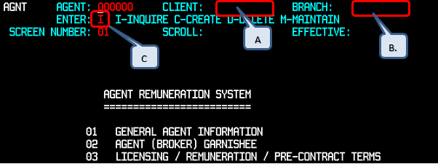  - CLIENT: Enter the advisor’s Client Number (NAAD) that was generated on the NAAD screen earlier.  - BRANCH: Enter the SL branch code. (It has 5 letters.)  - ENTER: Enter ‘C’ for create.  - Press Enter.  - Verify if the correct agent name is displayed.  - Press Enter again The new advisor code is generated.  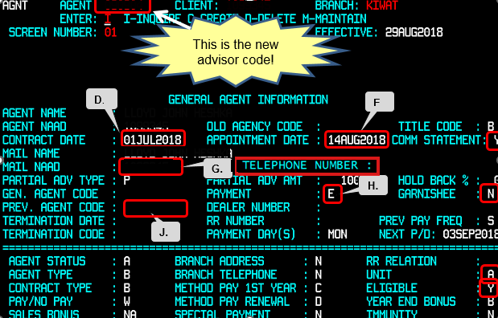  - Note the AGENT number generated on AGNT 01. Enter new SL code in the case comments in AWD.  - CONTRACT DATE: Copy the contract date from the DSS  - APPOINTMENT DATE: Enter today’s date.  - COMM STATEMENT: Y = mail paper statements to advisor, N = Do not mail paper statements to advisor.  - Use N for National Accounts and any NVEST advisors.  - Use Y for all other codes.  - MAIL NAAD: If commissions are paid to the individual or corporation, leave the default number. If commissions are paid to a third party (Direction of Commission or BVEST), enter the NAAD from the BVEST code.  - PAYMENT: Change to E (Electronic Fund Transfer). C is the default (for Cheque). If no banking info is available in FASAT, leave the PAYMENT field as C. After entering the override key on AGNT 03, return to AGNT 01 and change the PAYMENT DAYS(S) field to ‘15’ and the PAY/NO PAY field to ‘M’ for monthly.  - GARNISHEE: N is the default. If the advisor has existing SL codes, check AGNT 01 of each code and verify if the GARNISHEE field is Y or N. If Y, new SL code will need to be set to Y – refer to Garnishee procedure.  - PREVIOUS AGENT CODE: (Refer to step 12 for guidelines)  - If the advisor is vested, leave blank.  - If the advisor is non-vested, enter ‘NVEST’.  - If a corporation with NVEST advisors underneath, enter ‘BVEST’.  - UNIT: Enter the Unit as per SAS (e.g., A for GA, B for AGA, etc.).  - ELIGIBLE: Enter Y if the advisor is eligible; N if ineligible  - Corporations = N  - Individuals = Y (Exception: N for individuals under branches appearing on “not eligible” list)  NATIONAL ACCOUNTS NOT ELIGIBLE FOR CONTESTS  AON REED "AO" Offices  BMO "NB" Offices F9185  Cannacord "CA" Offices  CIBC Wood Gundy "WG" Offices F9280  Plus CIBCW MIDBK  QGOLL MWCBK  PPI Partners PPMBK PPCBK  PPIBK PPQBK  PPEBK PPTBK  PPWBK PVIBK  RBC RBCBK F9190  RBCBC RBCPR  RBQBK  Scotia "SC" Offices F9155  TD "TD" Offices F9834  M. TELEPHONE NUMBER: Copy the phone numberfrom the DSS  - Press Enter
14 | Locate the advisor license information  You will need this license information for steps #16 and #17.  Note: An advisor or corporation may be licensed in more than one province. Use the license number of the advisor’s primary address (eg. if the advisor resides in Ontario, you will require the Ontario license number).  Note: If advisor is contracting with a Bank NAC Branch (ie: BMO), A&S license is not required. You can proceed with only a life license.  Go to the license tab of DSS. If there is licensing information AND there is a future expiry date, use the information on DSS.  If the license number is not on DSS OR the expiry date is in the past OR the expiry date is an unrealistic future date (ie. January 1, 2099), go to the Advisor or Corp’s provincial website using the Licensing page, and follow the rules outlined on the licensing page. In addition:  - Ensure the license is Active  - Complete the license number and province on Capsil  - PDF the license to attach to the CSD  **Notes:  - The licensing date is the date of the request of the IC selling code.  - GWL/London Life: Licensing exception (insurance carrier themselves so the licensing is different). Go to FSCO > from home page click on Insurance - For Industry > under Licensing & Registration - Other Requirements - Click on Companies > there is a link to a list of Ontario Licensed Insurers > Find the entity.  - If the entity does not sell their own insurance, search the licensing normally as noted above (ie. Edward Jones).  - For additional NAC Licensing information, refer to: https://mfc.sharepoint.com/sites/iwmoperations/YodaV2/Yoda/Contracting%20Team/MBPS_Contracting/nac_code_set_up.aspx
15 | Enter more advisor information on AGNT 03  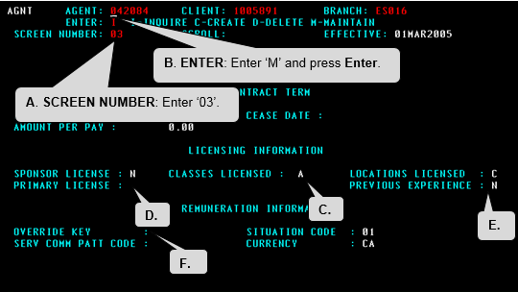  - From the AGNT 03 screen in Capsil:  - CLASSES LICENSED: Leave the default value, A.  - PRIMARY LICENSE: Enter the advisor’s license number.  - Note: An advisor or corporation may be licensed in more than one province. Use the license number of the advisor’s primary address.  - Exceptions: New Brunswick (NB) and Manitoba (MA) have only one license for both individual and corporation - Use same license number for both NVEST & BVEST, where applicable. (ownership of corp is not relevant)  - PREVIOUS EXPERIENCE: Enter ‘Y’  - OVERRIDE KEY: If the override key is available and required, enter it (from SAS or “Copy of SAS System Branches” Excel spreadsheet – see column I).  Leave the default SITUATION CODE, 01.  If there is no override key (e.g., GROUP codes do not have any override keys), leave the OVERRIDE KEY field blank and enter NO in the SITUATION CODE field.  - On AGNT 3, enter the advisor’s information into the appropriate fields.  - Press Enter.
16 | Enter the advisor’s license information on LTAB  On the LTAB screen, enter the license information. Use the province of the advisor. Refer to the advisor’s address in DSS.  For step-by-step details on how to set up the advisor’s license, refer to the Licensing page, and follow the rules outlined on the licensing page.  All of Canada except for Quebec codes are as follows:  - Go to the LTAB screen:  - TYPE = SL code  - LOCATION = 2 letter province code for where the advisor is licensed  - ENTER = Change the I to C for create and hit enter key  - Enter the data:  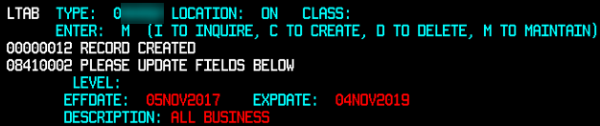  - LEVEL = leave blank  - EFFDATE= effective date in DSS, or on license  - EXPDATE= expiry date in DSS, or on license (For provinces that do not have an expiry date, enter the expiry date as the contract date plus a year, less a day (ie. contract date = March 5, 2015 then license expiry date = March 4, 2016)  - DESCRIPTION = ALL BUSINESS  - If you are viewing the LTAB, it looks like this:  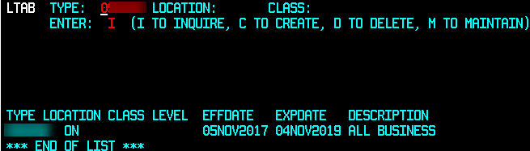  LTAB Exceptions  - Nova Soctia (NS): no effective date listed on license – subtract 3 years from expiry date.  - New Brunswick (NB) and Manitoba (MA): Only one license for both individual and corporation. Use same dates on LTAB for both NVEST & BVEST, where applicable.  - Quebec = use today’s date as effective date and add 1 year, minus 1 day for expiry date  Example of Quebec license for INDIV BUSINESS ONLY  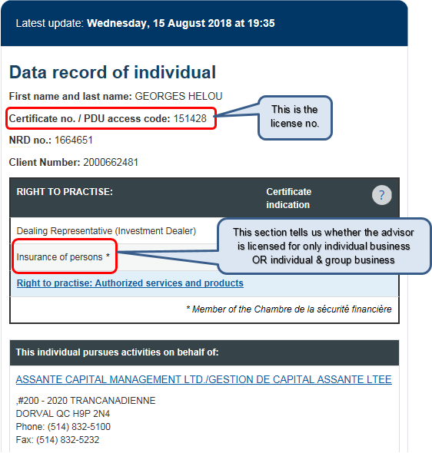  Example of Quebec license for INDIV BUSINESS & GROUP  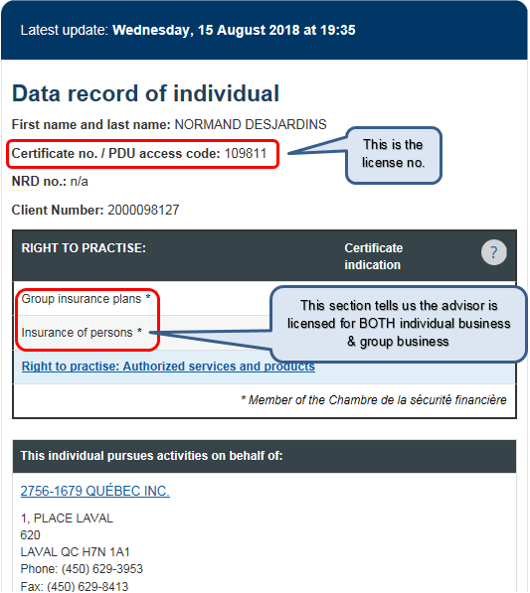  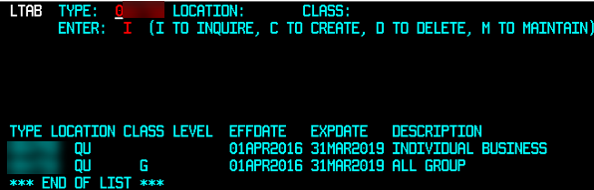
17 | Go to the NAAD screen. Ensure the Client Number (NAAD) is that of the advisor just created.  . 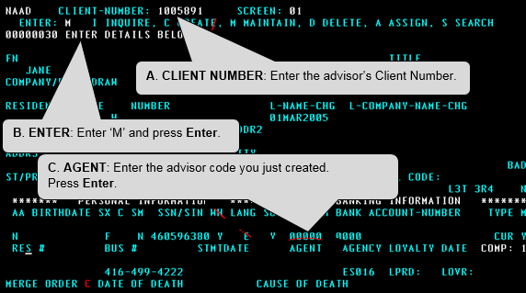
18 | If a Corporate Standard Life Code (ie. BVEST) has been set up, a Standard Life code for the rep (ie. NVEST) needs to be set up now using the previous steps.
19 | Once the advisor code has been created, send a confirmation email from DS New Contract Administration inbox to the appropriate party, as illustrated in the table below.  Once sent, attach the email(s) to the CSD in AWD.  Notification guidelines  Request is for Who to notify What to send Language  All individual advisors except for MANLF (IAC) & National Accounts (NAC) TO: MGA (GA) – get MGA email address from Lotus Notes – Stoplights. **Note - Use the e-mail for Contracting inquiries. If you are unsure, reach out to a Contract Administrator for help. BCC: Internal Requestor (if there is one) “New selling code for…” confirmation email (See Appendix A for) Refer to DSS (General Tab, Communications Preferences)  MANLF (IAC) individual advisors TO: Individual advisor – get advisor’s email address from DSS (contact info) BCC: Internal Requestor (if there is one) “New selling code for…” confirmation email (See Appendix A) Refer to DSS (General Tab, Communications Preferences)  National Accounts (NAC) TO: NAC contact from the NAC Spreadsheet / Distribution Channels Database BCC: The Requestor “New selling code for…” confirmation email (See Appendix A for) Refer to DSS (General Tab, Communications Preferences)  Corporate advisor TO: No notification required – ensure new SL code is added to DSS N/A N/A  Group Code TO: The requestor Reply to request and provide name, MLI code, new SL code-Branch (include BVEST code if applicable) English
20 | To add the new SL selling code to the existing MLI code in DSS, from the main Global Search screen, in the Code field, select Equals (=) and type the MLI selling code.  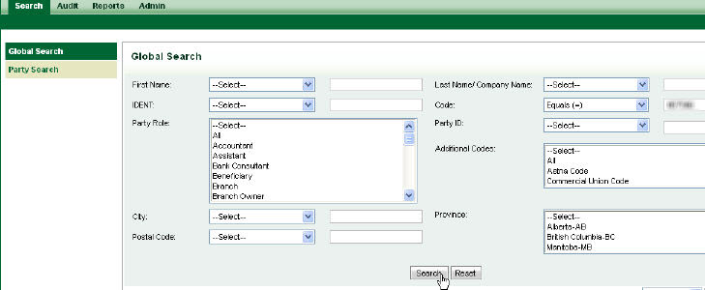  Click Search.
21 | Open the record by clicking on the code hyperlink.
22 | The Contract Management screen will be displayed. Click on Codes.  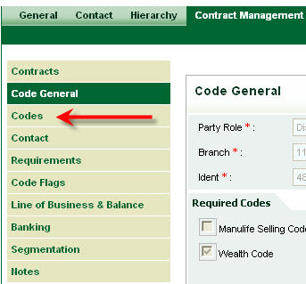
23 | Complete the following fields:  - Code Type = Standard Life Code  - Status = default  - Code = SL selling code (numeric)  - Branch Code = SL Branch code (alpha)  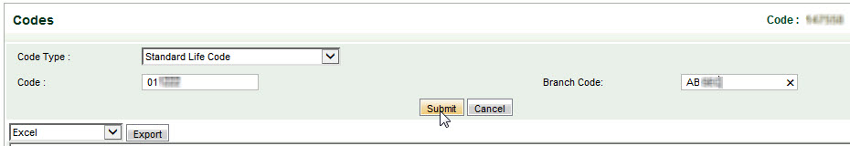  Click Submit.  **Note:  - SL branches are typically 5 characters with the codes being 6 digits (ie. WCSJB 012345). FundSERV branches and rep codes are typically 4 characters (ie. 3851 ABCD).  - Special circumstances may arise where a terminated SL code does not exist in DSS and now needs to be added (ie. advisor wishes code included in buy/sell).  - You can MODIFY existing SL/CRO codes on DSS, however, only Specialist role in DSS can REMOVE codes. If you need to request a code removal, please contact DS_Contracting@manulife.com.
24 | When a Capsil CRO code is provided, complete the following fields:  - Code Type = CRO Sovereign Code  - Status = Active/Terminated (status of MLI selling code)  - Code = SL Capsil CRO code (alpha numeric or numeric)  - Branch = SL Branch code (alpha)  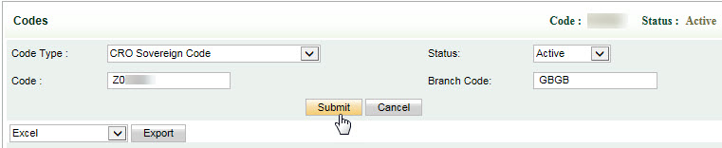  **Note: The Capsil CRO code will typically start with “S” or “Z”. The code could be similar to the SL code but the branch will then be different.
25 | Update the details and add note on CSD: “Will do CAMS tomorrow.”  Pend1 the CSD
26 | CAMS: Set-up online access next day  Login to CAMS using your Manulife mainframe ID and password (same as logging into your computer).  NOTE: CAMS set-up is now required for the Group code (Eff September 04,2020)  Overview:  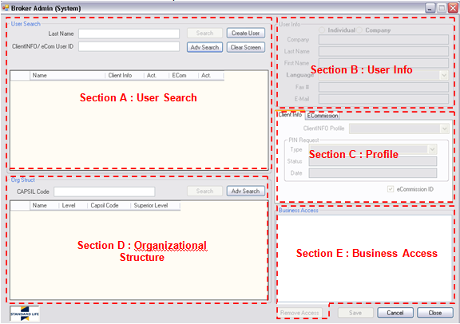  Section A – User Search: To search for an existing user or to verify if a user already has access.  Section B – User Info: To enter basic user information when creating a new user.  Section C – Profile: To give the appropriate ClientINFO and/or eCommission access.  Section D – Organizational Structure: To look-up codes or branches.  Section E – Business Access: To allocate the codes and or branches to which the user is entitled.  **Note:  - Best practice - when adding the new Capsil-MTL code(s) to an existing User ID, ensure to drag and drop them at the top of the list. (The reason for this is that the system uses the address associated with the top code for any adhoc mailings. Older codes may have a bad address.  Example:  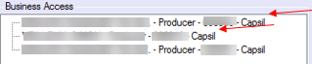  - This does not apply to Capsil-CRO codes (Z codes)  - Perform a user ID search in the top left corner (Section A)  - If you find an existing user ID, verify the status and type of access. To use an existing user ID:  - The “Act.” column must be Y (for active)  - The Client Info and ECom access must match the type of access your new code(s) should have  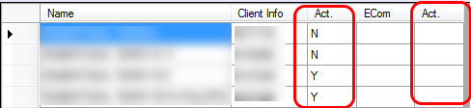  CAMS Scenarios  - Vested (individual)  - New user ID:  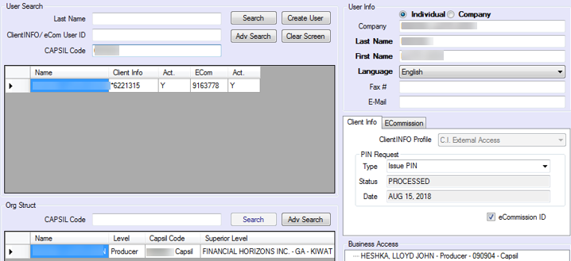  - Existing user ID:  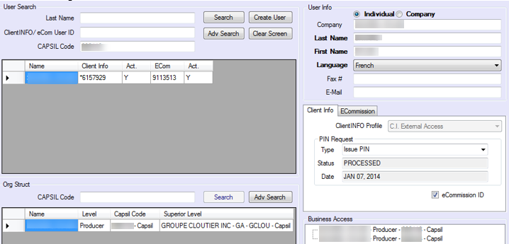  - NVEST–BVEST where the NVEST is 100% owner of the corp OR partial owner of the corp  - New user ID:  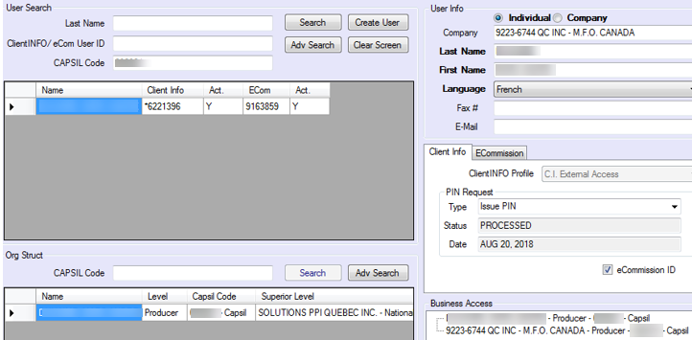  - Existing user ID:  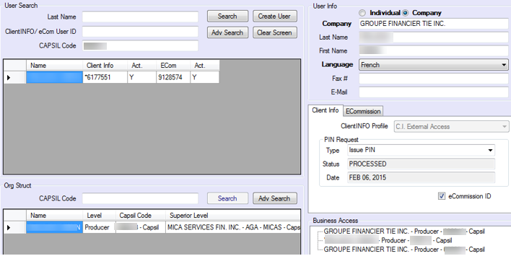  - NVEST-BVEST where a different individual owns the corp – 2 user IDs required: 1 for indiv (no ecom), 1 for corp  - Individual (NVEST):  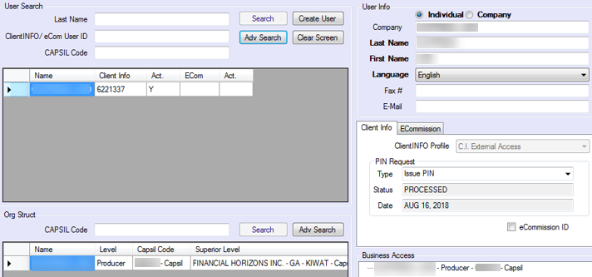  - Corp (BVEST): enter owner of corp’s name in Last & First Name fields  – Look up corp in DSS and click on name of the corp – see Relationships table:  - 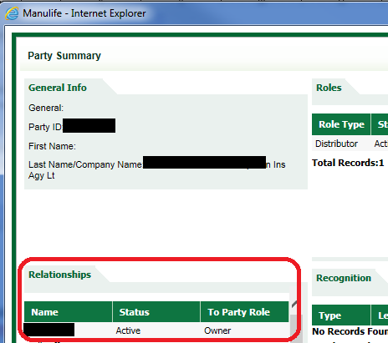u  - If you can’t find the corp owner under Relationships, check Party Notes:  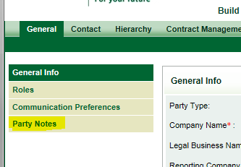  - If there is more than owner, use the first name listed in DSS  - If name of owner can’t be found, leave Last Name and First Name fields blank in CAMS  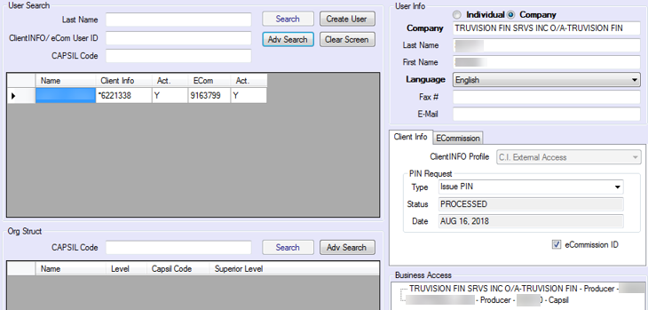  - NVEST-BVEST where another corp owns the corp – 2 user IDs required: 1 for indiv (no ecom), 1 for corp  - Individual (nvest)  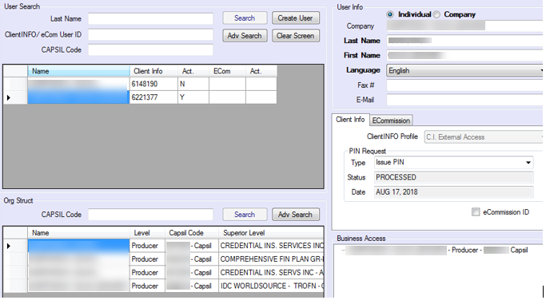  - Corp (existing user ID):  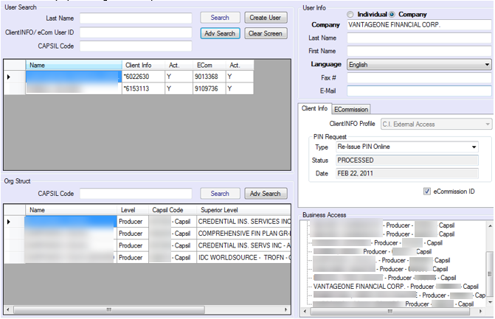  - National Account advisors – NO ECOM  NOTE: Create or use existing user ID for individual (NVEST) only – no need to add access for National Account  New user ID:  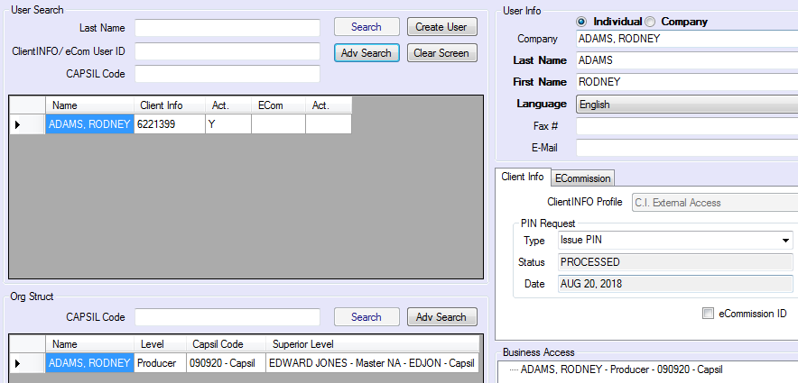  - Group code – ECOMM access only  NOTE: NVEST–BVEST: Create or use existing user ID for corporation (BVEST) only – just add the individual code into the corporation access.  If the individual is the corp’s owner - enter the name in Last & First Name fields  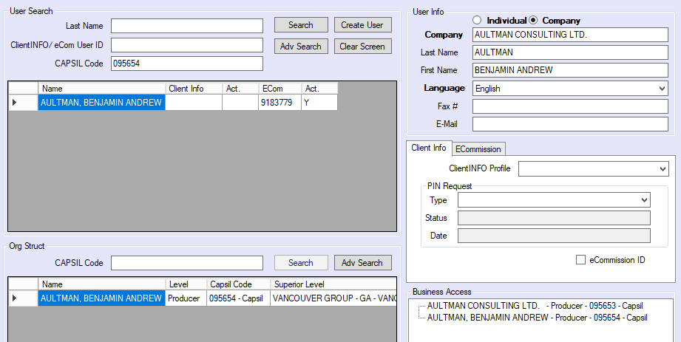
27 | Close case in AWD  - Attach notification email(s) to the CSD.  - Ensure you have First Name, Last Name, SL Code, Branch Code, Branch Name, MLI Code, Party ID  - Update CSD as “PROCESSED” status, and click “Update”

Code Movement
Step | Action
1 | Select the radio button beside the party record to which the selling codes will be moved from. Click the Code Movement button at the bottom of the results window.
2 | Once the code movement screen is open, you will see that all idents, codes, and other codes associated with the selected party are displayed in the Relinquishing Party section on the left-side of the screen.
3 | Select Within Party from the drop-down box labelled Type of Movement to move a code within the same Party ID.  Select Across Party from the drop-down box labelled Type of Movement to move between two different Party IDs.  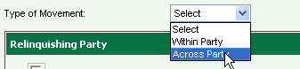
4 | If you have selected Across Party The right side of the screen now contains a hyperlinked Search selection.  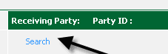  Click this hyperlink to reveal the party search screen.
5 | Conduct a search to locate the party to which you would like to move the code(s).  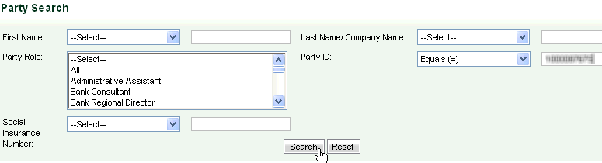  Click Search.  **Note: Operator LIKE can be used and then only enter the last 5 digits of the party Id (from new selling code)
6 | Once the result is displayed, select the radio button and click Submit.  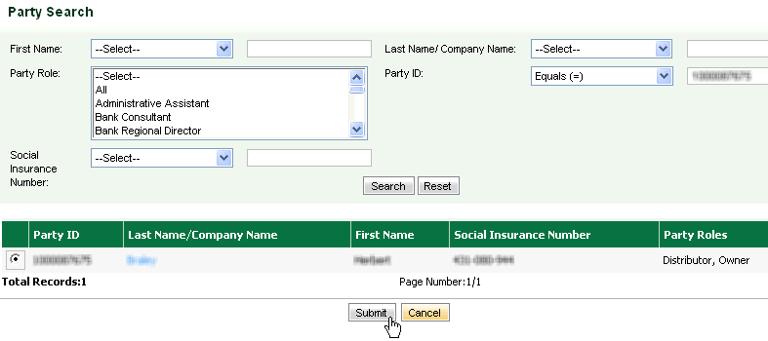
7 | The Relinquishing party on the left side of the Code Movement screen will be displayed the FUNDSERV code..  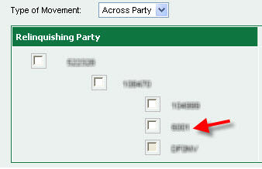
8 | In the Receiving Party section click on the selling code you want it to move to.  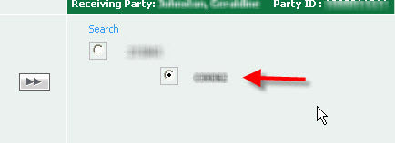
9 | Click the arrow button in the middle of the screen.
10 | The code will be moved to the Receiving Party. Click Submit.
11 | A confirmation message will be received. Click Yes.  
12 | Once Code movement has been completed you will need to check the contact info in DSS and ensure that all correct contact info is associated.
13 | Change the status of the CSD to PNDMESSAGE and click Update.  The transaction will “sleep” for 20 minutes to allow for updates to be fed to the BOS. The transaction will automatically be returned to you for processing and will be received when you click ‘Get Work” with the Status of PROCEED.
14 | Once you have processed the code movement you can update your CSD as follows:  - Complete the appropriate info (including name, selling code, etc.)  - Attach any documents  - Add any applicable Comments  Change CSD status to PROCESSED and click Update.

Distribution Channels Database
Step | Action
1 | Search Key Contacts in the left toolbar.  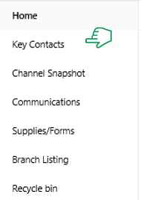
2 | Use the Search field in the top middle of the screen to enter the branch number and click to open.  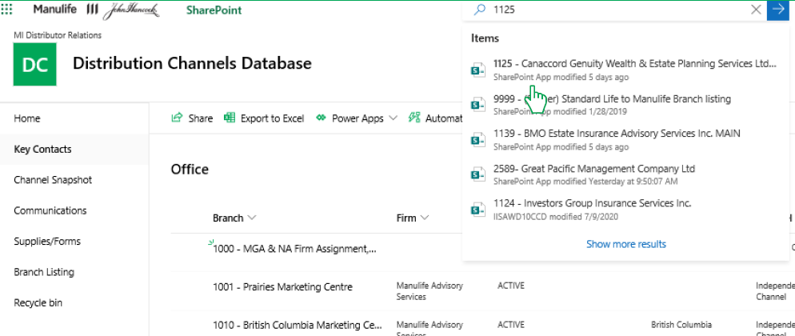
3 | Some branches will refer you to a different branch for contacts. Refer to the other branch if instructed to do so. If not, proceed to next step.  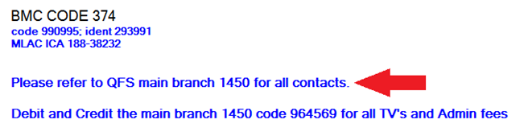
4 | Use the branch e-mail address that is listed for Contracting. This information can be found in multiple places:  1. Look for contracting instructions in the branch info section.  2. Look for “Contracting” under Title/Department column.  3. If unable to find contracting instructions, reach out to a Contract Administrator/Specialist.

Appendix A — Confirmation emails

English
Subject: New selling code for [ADVISOR FIRST & LAST NAME] for business of the former Standard Life - MLI [MLI SELLING CODE]

Hello,
We have received a request to provide a new selling code which will allow you to sell and service products which are considered part of the product line of the former Standard Life under your existing contract with Manulife. The terms of your existing Manulife contractual agreement will apply to sales and servicing activities related to the former Standard Life in addition to Manulife-originated products that are identified in the current product and compensation schedules available on Repsource.
The broker code [SL CODE – BRANCH] has been created and activated. You should use this code to submit business from the product line of the former Standard Life. Please continue to use your active Manulife selling code(s) and Fundserv code (if applicable) to submit business for products which originated from Manulife. Our Schedule of Commissions, Override and Recognition Credits identifies any products of the former Standard Life for your reference.
This process of using two separate selling codes for each product line is an interim solution until we fully integrate all systems. Once this occurs, we will communicate all changes, including processes for submitting business and obtaining compensation information. All compensation payments associated with the sale of products of the former Standard Life will be paid to you separately from your other Manulife compensation on separate compensation statements until further notice.
For information about products of the former Standard Life, including access to marketing materials, calculators and tools, please visit Repsource and click on “SL Advisor Portal login button” under the login window.
If you have questions about commissions or products of the former Standard life, please call the contact centre at 1 888-841-6633.
For questions related to contracting or commissions earned on Manulife-originated products, please contact the Distributor Contact Centre at 1 800-838-7770.
Thank you,
Distributor Services, Insurance & WAM Canada
STATEMENT OF CONFIDENTIALITY The information contained in this email message and any attachments may be confidential and legally privileged and is intended for the use of the addressee(s) only. If you are not an intended recipient, please: (1) notify me immediately by replying to this message; (2) do not use, disseminate, distribute or reproduce any part of the message or any attachment; and (3) destroy all copies of this message and any attachments.

French
Subject: Nouveau code de vente pour [ADVISOR FIRST & LAST NAME] pour des affaires de l’ancienne Standard Life - MLI [MLI SELLING CODE]

Bonjour,

Nous avons reçu une demande pour un nouveau code de vente qui vous permettra de vendre et d’offrir des produits qui font partie de la gamme de produits anciennement sous le nom de Standard Life en vertu de votre contrat existant avec Manuvie. Les modalités de votre entente contractuelle avec Manuvie s’appliqueront aux activités de vente et de prestation de services relatives à l'ancienne Standard Life en plus des produits propres à Manuvie présentés dans les barèmes sur les produits et la rémunération actuels, accessibles à partir d'Inforep.

Le code de courtier [SL CODE – BRANCH] a été créé et activé. Vous devez utiliser ce code pour soumettre des affaires visant les produits de l’ancienne Standard Life. Pour soumettre des produits propres à Manuvie, veuillez continuer à utiliser votre(vos) code(s) de vente Manuvie actif(s) et code Fundserv (le cas échéant). Notre Barème des commissions, des crédits de surcommissions et des crédits de reconnaissance indique tous les produits anciennement sous le nom de Standard Life.

L’utilisation de codes de vente distincts pour chaque gamme de produits est une solution temporaire qui s’appliquera jusqu’à la pleine intégration de tous les systèmes. Une fois complétée, nous communiquerons tous les changements, y compris les renseignements sur la rémunération et le processus pour nouvelles affaires. La rémunération découlant de la vente de produits anciennement sous le nom de Standard Life vous sera versée séparément de celle liée aux autres produits de Manuvie et déclarée sur des relevés de rémunération distincts jusqu'à nouvel ordre.

Pour obtenir des renseignements sur les produits anciennement sous le nom de Standard Life et accéder notamment à du matériel de commercialisation, des calculateurs et autres outils, veuillez consulter la Inforep et sélectionner « Entrer portail des conseillers à la SL ».

Si vous avez des questions sur les commissions ou les produits de l’ancienne Standard Life, communiquez avec le centre d’information au 1-888-841-6633.

Si vous avez des questions concernant la mise sous contrat et les commissions relatives aux produits propres à Manuvie, communiquez avec le Centre d’information des distributeurs au 1 800 838-7770.

Cordialement,

Services aux distributeurs, Assurance-Vie & Gestion de Patrimoine et d’actifs au Canada

ÉNONCÉ DE CONFIDENTIALITÉ Les renseignements contenus dans le présent courriel et toute pièce qui y est jointe peuvent être confidentiels et privilégiés en vertu de la loi, et ils sont destinés uniquement au(x) destinataire(s) prévu(s). Si vous n’êtes pas le destinataire prévu, veuillez (1) m’en informer immédiatement en répondant au présent message, (2) vous abstenir d’utiliser, de diffuser, de distribuer ou de reproduire une quelconque partie du message et, s’il y a lieu, les pièces jointes, et (3) détruire toutes les copies du présent message et, s’il y a lieu, les pièces jointes.

Appendix B — Incorporation Template

Hello,
The advisor’s Standard Life code <SL Code – Branch> has been incorporated. Please proceed using this code.

Thank you,

DS New Contract Administration
T. 1-800-838-7770 | F. 519-747-6436
E. DS_New_Contract_Administration@manulife.com

Appendix C — How to delete banking info from NAAD2

If banking info on NAAD screen 02 is entered in error, follow these steps:

- Go to NAAD screen 01, paste the NAAD (CLIENT-NUMBER) in question and ensure name matches up.

- Go to NAAD screen 02: in ENTER field, change I to M to maintain:
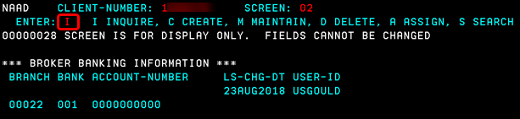

- Enter one asterisk (*) per field (Branch, Bank, Account-number) and hit enter key
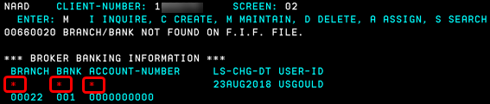

- This is what it will look like after:
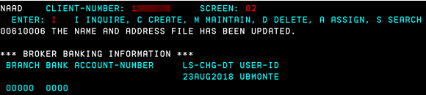

Appendix D – Decline E-mails

- Declined as suitable Manulife Contract is Required:
Hello,
We received your request to obtain a Standard Life selling code, however, we are unable to proceed as the <London Life> <Bank only> <Mutual Fund only> selling code provided is not eligible to receive a corresponding Standard Life code.
Since we could not locate an appropriate selling code that would enable you to sell insurance related products through Manulife and Standard Life, your request has currently been declined.
Questions
If you have any questions, please contact the Distributor Contact Centre at 1-800-838-7770 or email comp_mfc@manulife.com.
Thank you,
DS New Contract Administration
T. 1-800-838-7770 | F. 519-747-6436
E. DS_New_Contract_Administration@manulife.com

Appendix E – NIGO E-mails

Hello,
Thank you for your request to obtain a Standard Life selling code. Unfortunately, we are unable to proceed with the request until the below information is submitted:

Please provide the following information:
[NOTE: Include only necessary bullet points]
- First Name:
- Middle Name:
- Last Name:
- Active Manulife selling code:
- Date of Birth:

Questions
If you have any questions, please contact the Distributor Contact Centre at 1-800-838-7770 or email comp_mfc@manulife.com.

Thank you,

DS New Contract Administration
T. 1-800-838-7770 | F. 519-747-6436
E. DS_New_Contract_Administration@manulife.com

Appendix F – Not Active with Manulife
Hello,
We received your request to obtain a Standard Life selling code. Unfortunately, we are unable to proceed with the request as an active Manulife selling code is required for us to create a corresponding Standard Life selling code.
[NOTE: Include only necessary section]
(CAC/IAC): If you wish to contract this advisor to sell both Manulife and Standard Life business, please send the Advisor the appropriate web application link.
(Group): Please reach out to your assigned contact at your RGO to discuss acquiring an active Manulife Selling code.
(NAC): Please follow your regular Manulife contracting procedure and submit the Manulife selling code request form to comp_mfc@manulife.com with the subject line “Manulife selling code request”.
Once the Manulife selling code has been issued, kindly follow the below interim process:
- Email comp_mfc@manulife.com with the subject line “Standard Life selling code request”
- Provide the advisor’s first and last name
- Provide the advisor’s active Manulife selling code
- Provide the corporation’s full name, if applicable
- Provide the corporation’s active Manulife selling code, if applicable

Questions
If you have any questions, please contact the Distributor Contact Centre at 1-800-838-7770 or email comp_mfc@manulife.com.
Thank you,
DS New Contract Administration
T. 1-800-838-7770 | F. 519-747-6436
E. DS_New_Contract_Administration@manulife.com

Appendix G – Declined as suitable Manulife Contract is Required:

Hello,
We received your request to obtain a Group Only Standard Life selling code, however, we are unable to proceed. The Manulife selling code provided is not eligible to receive a corresponding Group Only Standard Life code.
Please work with your assigned RGO in receiving an eligible Manulife selling code.
Questions
If you have any questions, please contact your assigned RGO or Manulife’s Distributor Contact Centre at 1-800-838-7770 or email comp_mfc@manulife.com.
Thank you,
DS New Contract Administration
T. 1-800-838-7770 | F. 519-747-6436
E. DS_New_Contract_Administration@manulife.com

